Name: Home Group: Due Date:
Migration into Australia Assignment Option 3
You have been appointed by the Northern Territory government to help design the new city of Weddell.
New city, Weddell, to be built in Northern Territory

By Tara Ravens
AAP
February 04, 2009 02:43pm

THE Northern Territory will get a fourth city to cater for a massive population swell by 2030.

Darwin, Alice Springs and the satellite city of Palmerston will be joined on the map by Weddell within the next five years.

Almost 15km south of Palmerston, the 2000 hectare development will be called home by about 40,000 people.

"This is a very significant announcement - a fourth city for the Northern Territory," NT Chief Minister Paul Henderson said.

"The planning starts today and we will be turning off new lots in Weddell in five years time."

Speaking to an audience of business and community leaders in Darwin, Mr Henderson said the population of the Darwin and Palmerston areas was expected to increase 34 per cent by 2021.

By 2030, there will be an increase of 63,000 people, or 55 per cent, taking the population to 177,000.

"There would be few other communities in Australia today talking of the level of expansion we have forecast for Darwin and Palmerston," Mr Henderson said.

"There would be few other communities talking about the development of six new suburbs and a whole new city."

Mr Henderson said the Government could not afford to delay the planning, with this sort of growth equating to about 1700 new houses every year, 172 more police, 293 additional nurses, 54 doctors and 121 hospital beds.

There will also be more than 7000 new students needing about 430 additional teachers.

"We will be pretty damn busy in the next 20 years," Mr Henderson said.

But the Government does not plan on going it alone.

"We will be developing the Territory hand in hand with the private business and development sector and the non-government community sector," Mr Henderson said.

Early estimates put the cost of providing the city's arterial roads, power, water and sewerage trunk services to come to about $740 million. The Government hopes these developments generate additional private investment of "at least several billion".

"At the moment, the Weddell locality is little more than unremarkable lines on a map," Mr Henderson said.

"Those lines will take shape as houses, shops, and schools, as parks and sporting grounds, as clinics and new businesses across four suburbs."

Source: http://www.news.com.au/story/0,27574...-29277,00.html

Develop the concept plan for Weddell. Think about the features that would help make the city sustainable and also make it an attractive place for residents to move to. Consider the following website to see where Weddell is located http://www.whereis.com/nt/weddell-0822 OR the map on the back of this sheet (taken from the whereis website)
Pearson Ch 13.6 (pp266 – 267) will be useful for this assignment.
Include a map for Weddell and some explanatory notes and reasons for your choices. (A4 page for map and around one A4 page of notes/reasons.)

MARKING RUBRIC IS ON THE BACK OF THIS SHEET

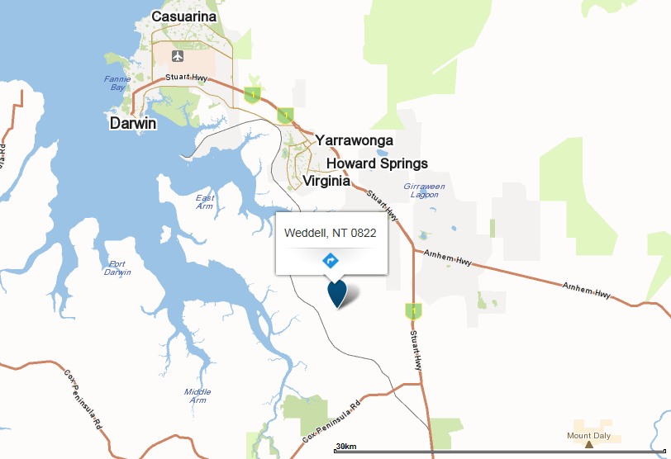

Year 8 Geography Achievement Standards

A | B | C | D | E
Comprehensively and effectively explains interconnections within environments and between people and places and explains how they change places and environments. | Proficiently and effectively explains interconnections within environments and between people and places and explains how they change places and environments. | Satisfactorily explains interconnections within environments and between people and places and explains how they change places and environments. | Partially explains interconnections within environments and between people and places and explains how they change places and environments. | Minimal explanation of interconnections within environments and between people and places and explains how they change places and environments.
Comprehensively compares alternative strategies to a geographical challenge and propose a response, taking into account environmental, economic and social factors. | Proficiently compares alternative strategies to a geographical challenge and propose a response, taking into account environmental, economic and social factors. | Satisfactorily compares alternative strategies to a geographical challenge and propose a response, taking into account environmental, economic and social factors. | Partially compares alternative strategies to a geographical challenge and propose a response, taking into account environmental, economic and social factors. | Minimal comparison of alternative strategies to a geographical challenge and propose a response, taking into account environmental, economic and social factors.
Comprehensively and effectively presents findings, arguments and ideas using relevant geographical terminology and graphic representations in a range of appropriate communication forms. | Proficiently and effectively presents findings, arguments and ideas using relevant geographical terminology and graphic representations in a range of appropriate communication forms. | Satisfactorily presents findings, arguments and ideas using relevant geographical terminology and graphic representations in a range of appropriate communication forms. | Partially presents findings, arguments and ideas using relevant geographical terminology and graphic representations in a range of appropriate communication forms. | Minimal presentation of findings, arguments and ideas using relevant geographical terminology and graphic representations in a range of appropriate communication forms.
Comprehensively and effectively proposes action in response to a geographical challenge taking into account of environmental, economic and social considerations and predict the outcomes of their proposal. | Proficiently and effectively proposes action in response to a geographical challenge taking into account of environmental, economic and social considerations and predict the outcomes of their proposal. | Satisfactorily develops proposes action in response to a geographical challenge taking into account of environmental, economic and social considerations and predict the outcomes of their proposal. | Partially proposes action in response to a geographical challenge taking into account of environmental, economic and social considerations and predict the outcomes of their proposal. | Minimal suggestion of action in response to a geographical challenge taking into account of environmental, economic and social considerations and predict the outcomes of their proposal.

Overall Grade & Comments:

